Some Life Changing methods

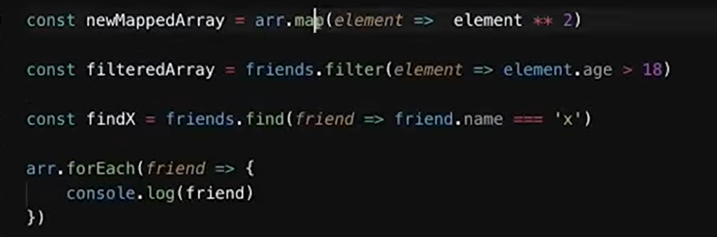

MAP => Don’t mutate old array

=> Always return new Array

FILTER => Don’t mutate old array

=> Return true /false based on a condition in array

=> Always return new Array

e.g.

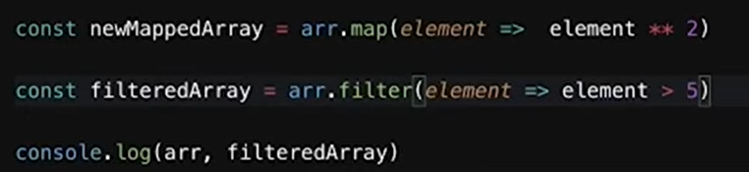

Filter also work for array of object like this

e.g.

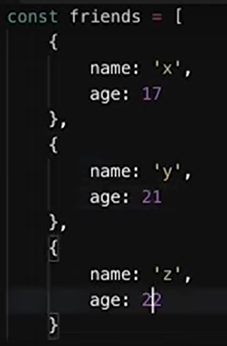

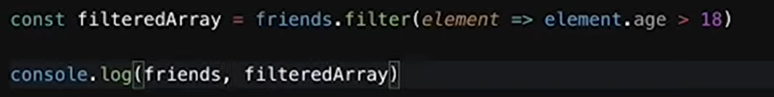

FIND for above Friends Array

=> Always return new Object

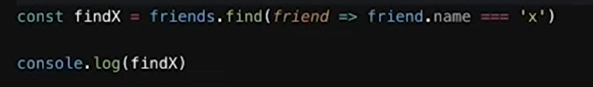

This results the whole object that have name = “x”

ForEach => Don’t return something

=> Act as a normal for Loop

=> Give you access to the values

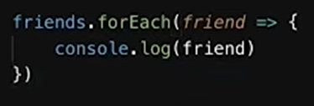

FOR Loop => Simply to iterate every value in array

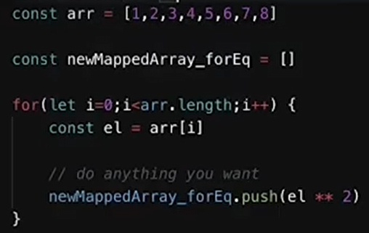

Concatinate without template Literals

e.g. “Hello ” + peron.name + “HRU”

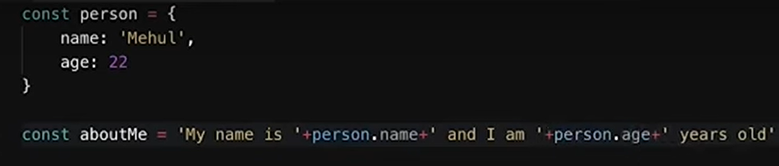

TEMPLATE LITERALS

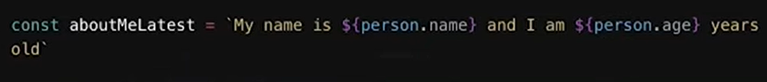

PROMISE

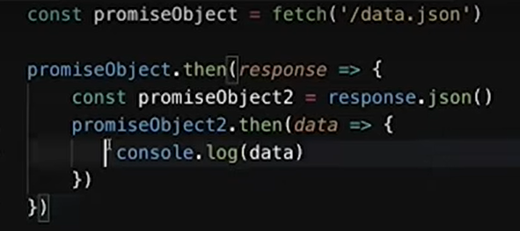

Same code with chainning

